**Model Optimization and Tuning Phase Template**

|  |  |
| --- | --- |
| Date | 3/7/24 |
| Team ID | SWTID1720100721 |
| Project Title | Machine Learning Approach to Predict Price of Natural Gas |
| Maximum Marks | 10 Marks |

**Model Optimization and Tuning Phase**

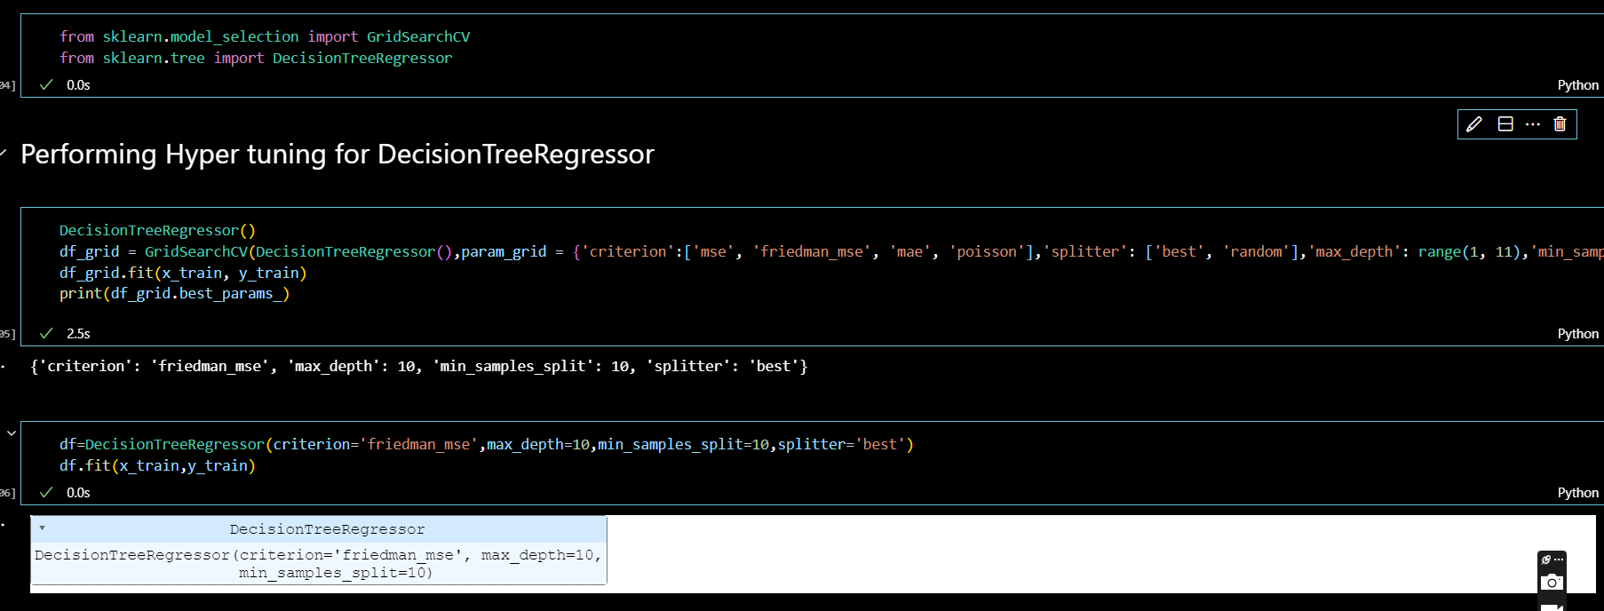

### Hyperparameter Tuning Documentation (6 Marks):

|  |  |  |
| --- | --- | --- |
| **Model** | **Tuned Hyperparameters** | **Optimal Values** |
| Model 1  (Decision Tree Regressor) | {'criterion', 'max_depth', 'min_samples_split', 'splitter' | 'friedman_mse', 10, 10, 'best' |
| Model 2  (Random Forest Regressor) | None | None |

### Performance Metrics Comparison Report (2 Marks):

|  |  |  |
| --- | --- | --- |
| **Model** | **Baseline Metric** | **Optimized Metric** |
| Model 1  (Decision Tree Regressor) | 0.9523145463412501 | 0.9683899463377701 |
| Model 2  (Random Forest Regressor) | None | 0.9857775116720077 |

### Final Model Selection Justification (2 Marks):

|  |  |
| --- | --- |
| **Final Model** | **Reasoning** |
| Model 2 (Random Forest Regressor) | Random Forest Regressor model has been selected, which outperforms the Decision Tree Regressor with a higher R2 Score and lower RMSE and MAE values. The ensemble approach of Random Forest Regressor reduces overfitting and captures feature interactions more effectively, leading to more accurate predictions. With its improved generalization capabilities, the Random Forest Regressor is a better choice for deployment. |